**COMMANDS** :

1. pwd

This command writes to standard output the full path name of your current directory(from the root directory).

All directories are separated by /(slash). The root directory is represented by the first / , and last directory named is your current directory .

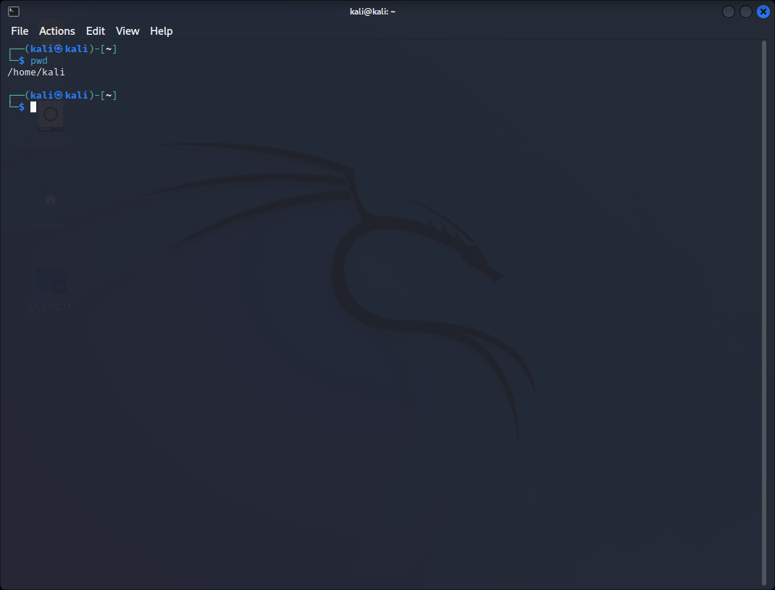

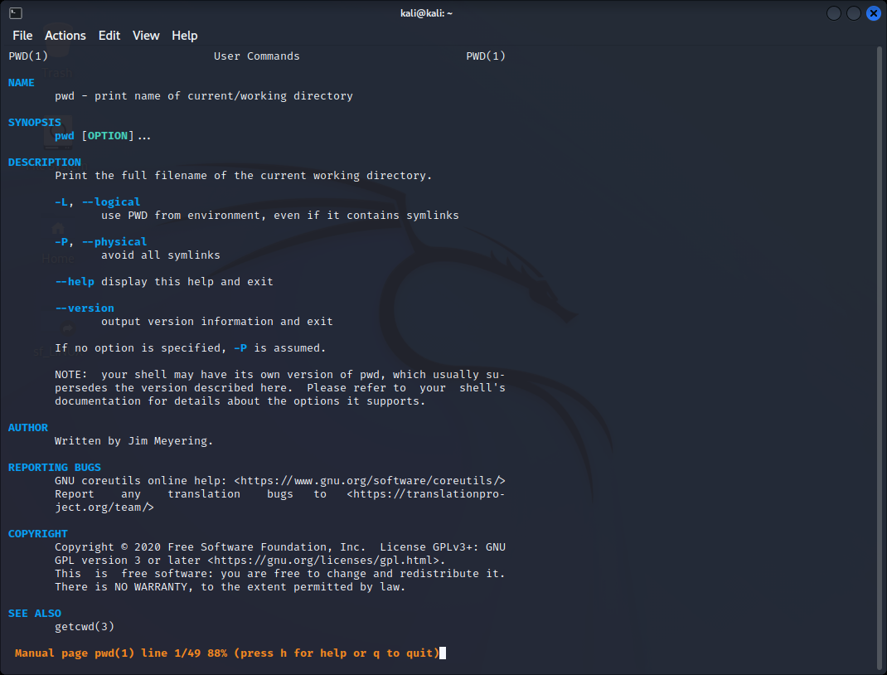

1. Ls

It is a Linux shell command that lists directory contents of files and directories . This is one of the basic commands known to all linux users .

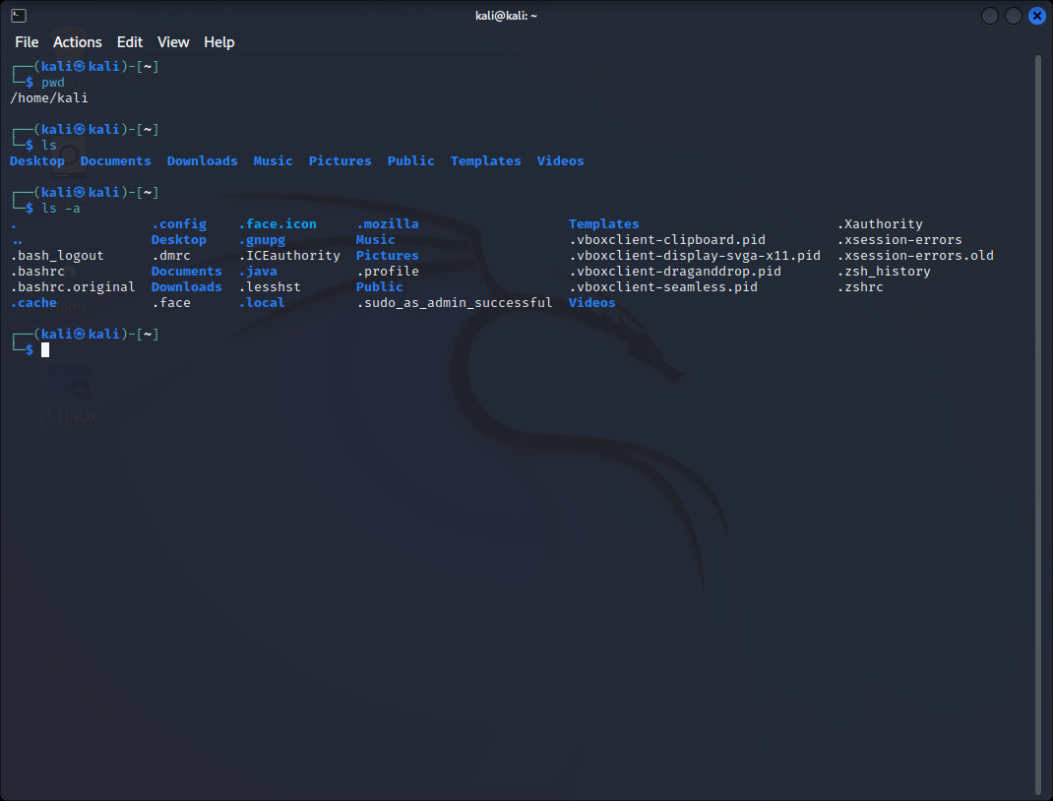

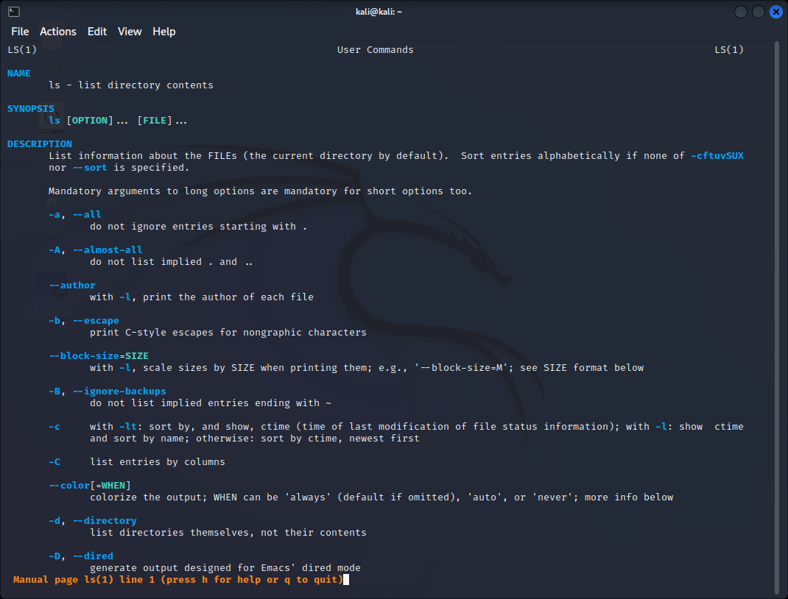

1. mkdir :

it allows the users to create or make new directories . mkdir stands for “making directory”. With mkdir , you can set permissions , create multiple directories ( folders ) at once .

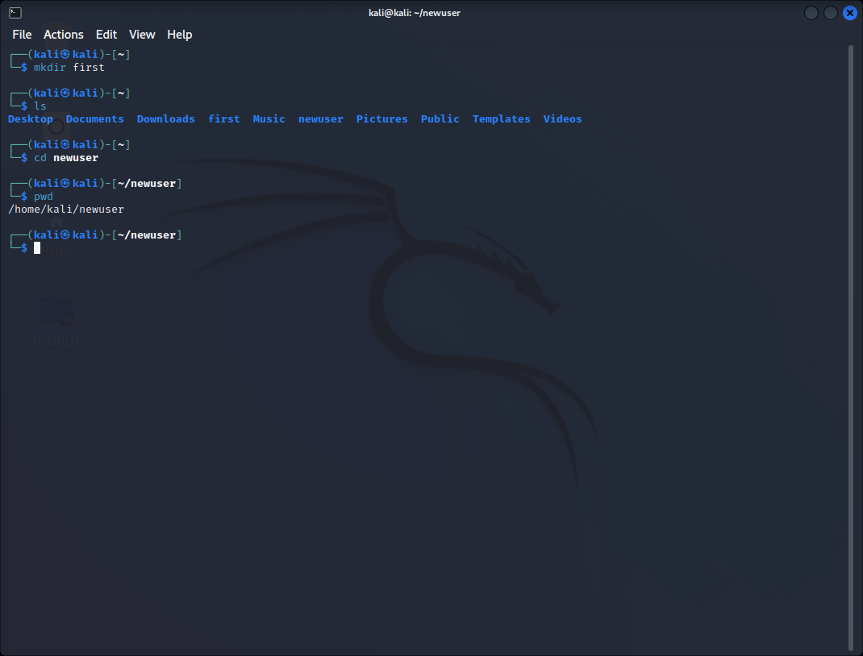

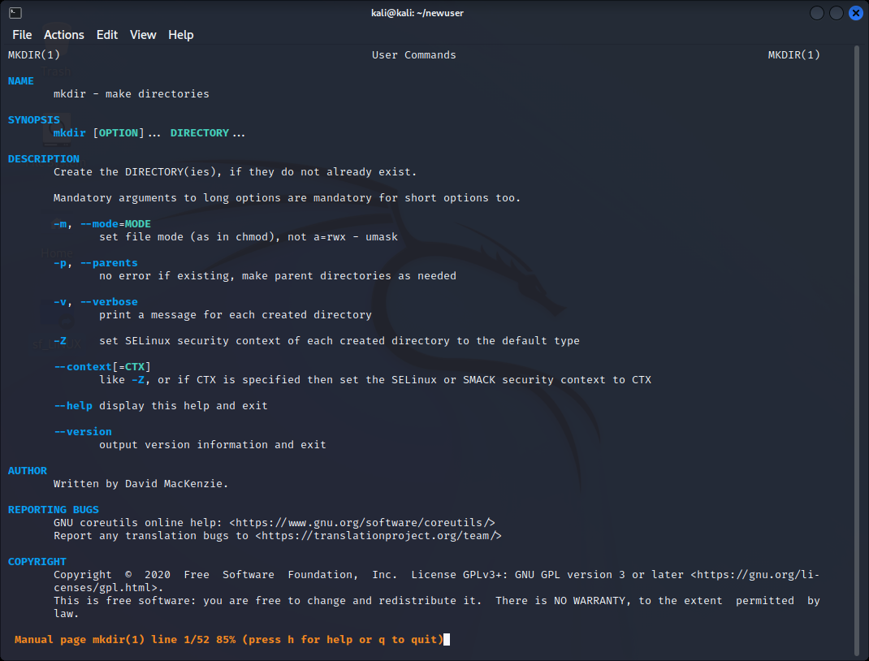

1. cd :

it is known change directory command . it is used to change current working directory . it can be used in shell scripts and batch files .

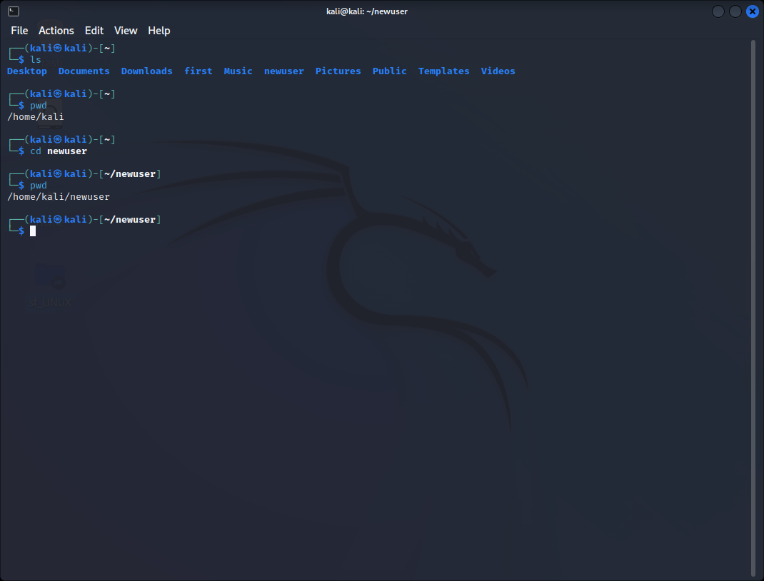

1. rmdir :

it is used to remove empty directories from filesystem in linux. The rmdir command removes each and every directory specified in the command line only if these directories are empty. So if the specified directory has some directories or files in it then this cannot be removed using rmdir command .

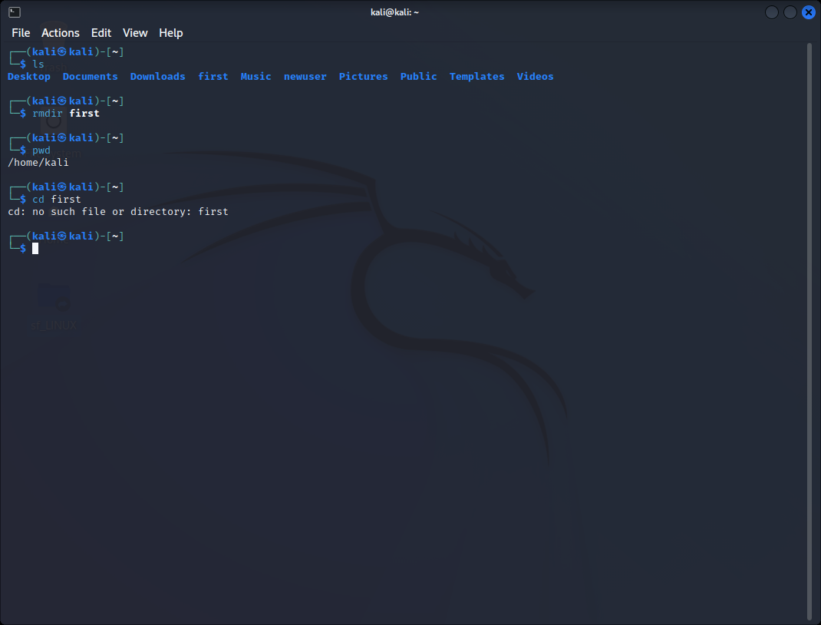

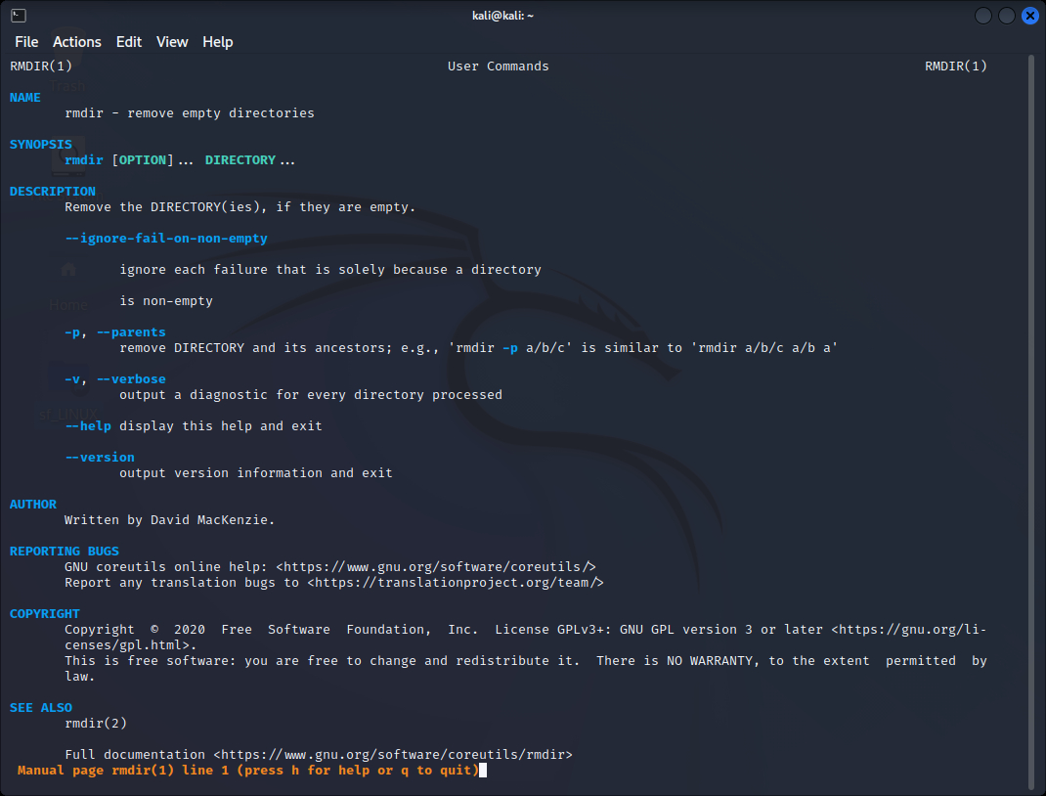

1. man :

This command is used to display the user manual of any command that we can run on the terminal . It provides a detailed view of the command which includes NAME , SYNOPSIS, DESCRIPTION, OPTIONS, EXIT STATUS , RETURN VALUES, ETC

